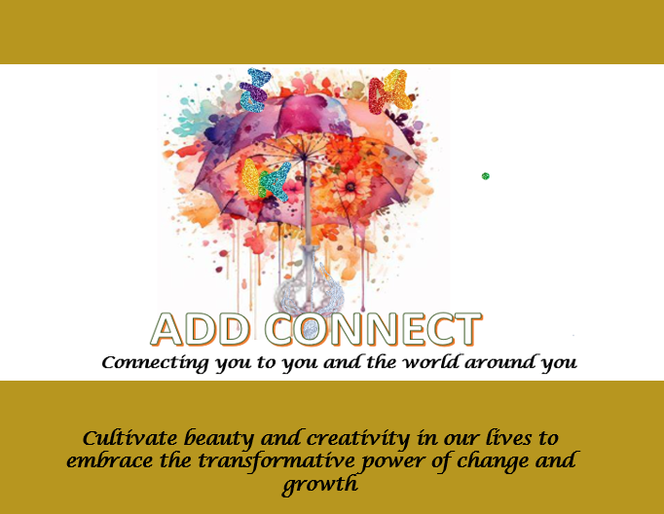

Company Profile

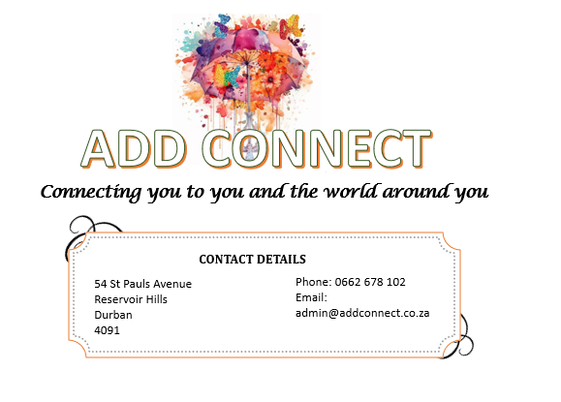

Table of Contents
1 About Us 4
2 Products and service offerings 5
2.1 Programs and Service for the Learning Environment 5
2.2 Programs and Service for the Social Events Environment 6
2.3 Programs and Service Offerings for the Corporate Environment 6
2.4 Our Products 7
2.4.1 The Baby Journal 7
2.4.2 The SMART Study Calendar 8
2.4.3 Perfumes for memory and concentration 9
2.4.4 Raksha Bandhan Wall Mat 10
2.4.5 Whispers from the Universe Affirmation Cards 11
2.4.6 Our Shadi Mubarak Game 12
2.4.7 Mehndi Games 13
3 Up and Coming Programs 14

ADD CONNECT
Connecting you to your world

About Us

Unleash the Power of Innovation & Creativity!
Are you ready to revolutionize your events and workshops? Do you want to inspire your audience, spark new ideas, and drive meaningful connections?
ADD Connect provides well-being and creative programs to unlock, empower, unveil, rediscover your -SELF and connect you to your inner self, your ambition, your goals, your family , your friends and your business partners.
As a leading Innovation and Creativity Consulting firm, we help you design and deliver unforgettable experiences that ignite imagination, foster collaboration, and drive results. Our expert team of facilitators and creatives will work closely with you to craft customized solutions that align with your goals and objectives for your event.
From ideation sessions to interactive workshops, our innovative approaches will:
- Boost engagement and participation
- Foster a culture of creativity and innovation
- Drive meaningful connections and networking
- Inspire new ideas and solutions
- Enhance your brand reputation and visibility

Whether you're looking to:
- Entertain and wow your guest at your party, at your pre wedding events, a high tea you hosting, your daughter’s 16th birthday party;
- Host a brainstorming session for your business team
- Create a memorable conference or summit
- Foster a culture of innovation within your organization

We've got you covered! Our expertise in innovation and creativity consulting will help you:
- Design and deliver impactful events and workshops
- Develop innovative solutions and strategies
- Foster a culture of creativity and innovation
- Drive meaningful connections and networking
Our programs are fun and event/scenario orientated hence they are customized to meet your needs. So , wherever it is in your phase of your life and the title you hold – be it a learner, scholar, employee, mum, dad, spouse, partner, business person or you are about to tie the knot, get ready for an EQ uplift and select a programme that you need. The ADD CONNECT team will provide a free consult and thereafter design a program to customized to meet your needs. See our service offerings below

Let's collaborate to create unforgettable experiences that drive results and unleash the power within you! Contact us to learn more and let's get started on your innovation journey! #InnovationConsulting #CreativityConsulting #EventDesign #WorkshopFacilitation #InnovationAndCreativity #EventPlanning #ConferenceDesign #SummitPlanning #TeamBuilding #Collaboration #Networking #Ideation #Brainstorming #CreativeSolutions #InnovativeApproaches"

Products and service offerings

Programs and Service for the Learning Environment

The ADD CONNECT TEAM in association with our specialist consultants from our ADD- educare business unit specializes in focused service offerings for the learning environment – be it school, tertiary or at work. Does not matter whether you are at foundation phase , senior primary , FET Phase , tertiary or at your work place. Through Iinnovation and creativity we offer creative problem-solving services using art and design thinking to drive innovation and growth. We can help you be a better you, unlock your true potential, and overcome challenges that has been hindering your success.
We have the programmes suitable for parents, learners and educators that will ensure that the value chain in the learning environment is robust and all parties objectives are met:
- Governance and ethics Management Workshop;
- Risk Management in the learning and teaching environment
- Educators Workshop – Management ; Online Platform tools and techniques
- Parenting Workshop- The New Generation; The Art of communication; quality time ;
- Young Entrepreneurs Development Programme
- Mentorship programmes from Grade RR to Grade 12;
- Holiday Club – filled with story telling , arts and craft with meals and snacks provided
- Goal setting Workshop for learners
- Value and Etiquette workshop
- Study and learning Techniques – A practical approach
- Learner wellbeing programs

Programs and Service for the Social Events Environment
Get ready to level up your social game! Our programs and services are designed to make your next social event a night to remember. From customized cocktail parties to interactive team-building activities, we've got you covered. Our expert team will work with you to create a unique and unforgettable experience that will leave your guests talking long after the party's over. Whether you're celebrating a milestone birthday, hosting a corporate event, or just looking to spice up your social calendar, we've got the perfect solution for you. So why settle for ordinary when you can have extraordinary? Let us help you create an event that's truly one-of-a-kind!
We have an array of fun filled activities very mindfully crafted to meet your needs at your event such as:
- Mehendi activities
- Activities for High teas and event
- Family team Building
- Coat of arms for Couples
- Activities for parties ( various age groups)
- Scrap Booking Workshops
- Perfume blending
- Mums club
#SocialEvent #PartyLikeAPro #EventPlanning #UniqueExperiences

Programs and Service Offerings for the Corporate Environment
Power up your work game with our cutting-edge programs and services designed to elevate your corporate events and workplace experience! From team-building retreats to wellness workshops, and from leadership development to employee engagement initiatives, we've got you covered. Our expertly curated offerings are designed to boost morale, foster collaboration, and drive results. Whether you're looking to celebrate a milestone, launch a new initiative, or simply show your team you care, we've got the perfect solution to make your event unforgettable. Let's get started and take your workplace culture to the next level!
- Goal setting Workshop
- Promoting ethics and integrity at the workplace
- Risk Management -the practical approach
- Value and Etiquette workshop
- Team Building customised to the theme of workshop
- The art of listening and conflict resolution
- Employee wellbeing programs
#CorporateEvents #WorkplaceWellness #TeamBuilding #EmployeeEngagement"

Our Products
Our products are customized and hand crafted by the ADD team. The following are :

The Baby Journal
This is the first ever in South Africa. Created and published by Anoshee Maharaj , this is a must for any Hindu Baby. Perfect for a baby shower or even a hand down gift on the eve of the wedding from parent to a daughter or son of their own baby journal.

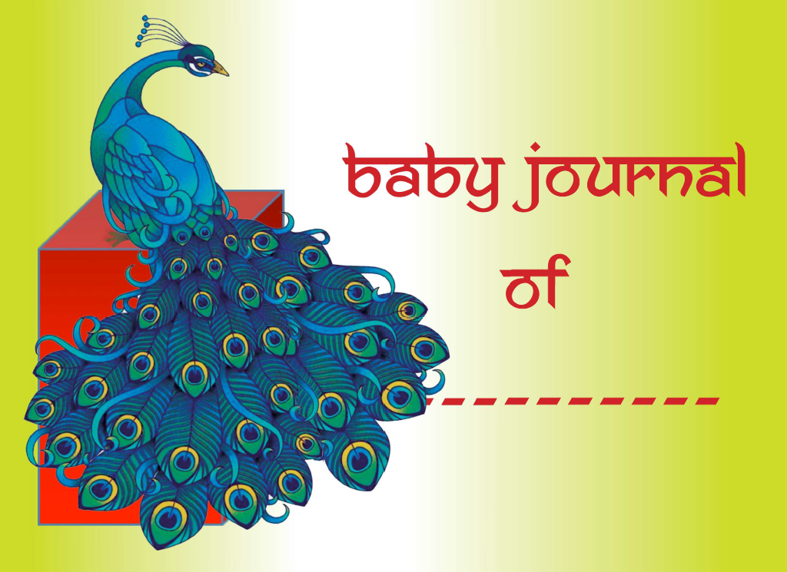

The SMART Study Calendar
This is a SMART calendar perfectly designed for effective planning and time management for all scholars. This calendar is a smart tracking tool for :
- Parents to monitor and have oversight over tuition sessions with external tutors and progress made by their children
- Dyslexic Learners;
- Scholars/ learners to identify and effectively mange study time and study technique.
- Engage the various study methods and techniques, which are critical to during the learning process. This ensures effective learning and recalling strategies are taking place
- The study calendar guide learners to use the SMART principles when planning for study hence ensuring optimal results are obtained
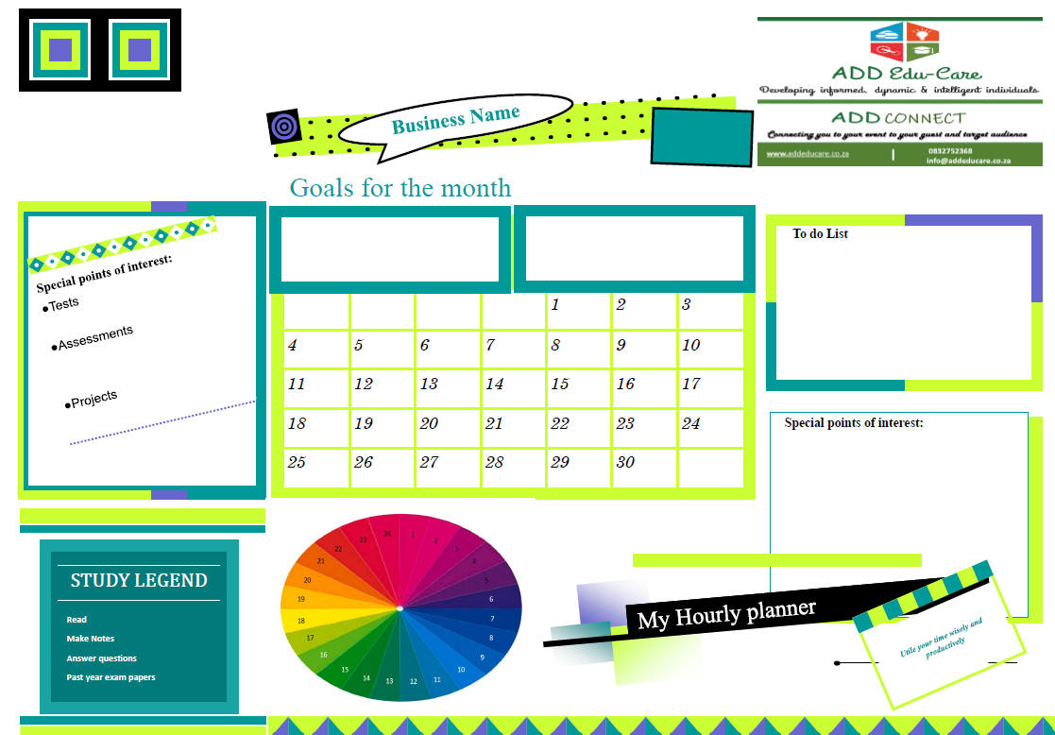

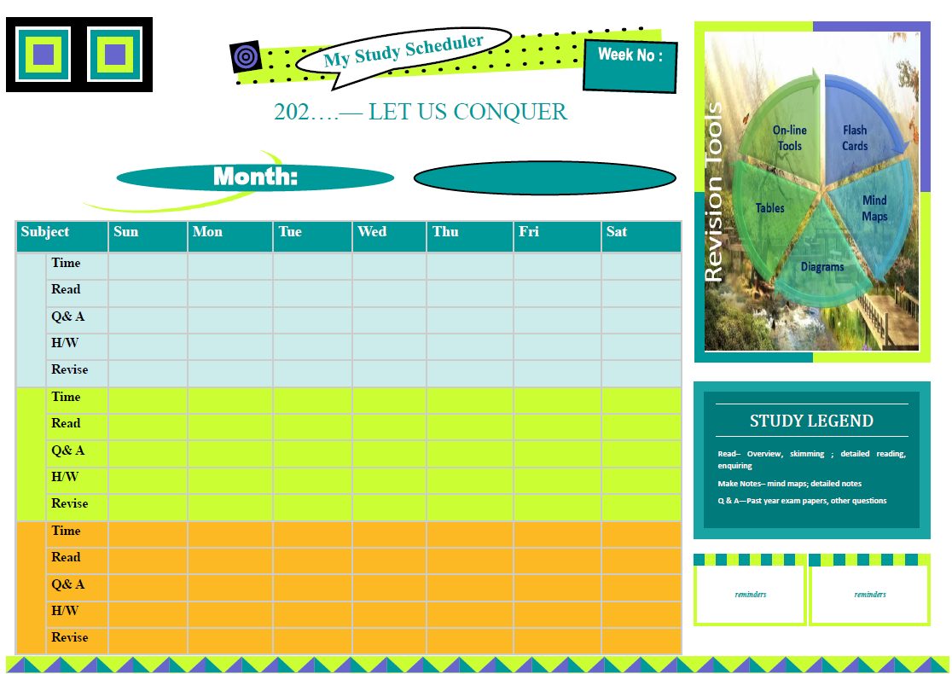

Perfumes for memory and concentration

Unlock the secrets of a sharper mind with our innovative essential oil-based perfume, designed to boost memory, focus, and concentration. We have blended our own SMART perfumes which are ideal to improve memory, focus and concentration. So I you are working long hours or burning the midnight oil ,try our special blends. . As you apply this perfume, the subtle yet potent aroma wafts up, transporting you to a state of mental clarity and precision. With its unique blend of cognitive-boosting essential oils, this perfume is the perfect companion for students, professionals, and anyone seeking to optimize their mental performance and achieve their goals.

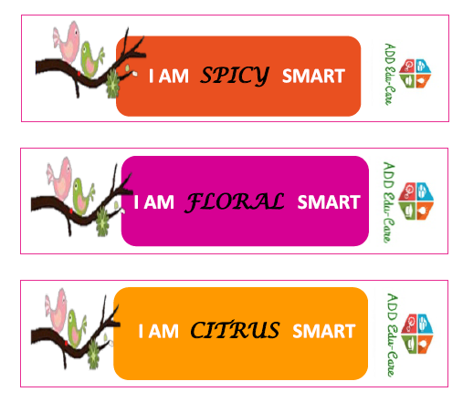

Raksha Bandhan Wall Mat

Raksha Bandhan, the sacred bond of sibling love and protection, is celebrated with great fervor and enthusiasm all around the world. And what better way to commemorate this special day than with a trendy Raksha Bandhan wall mat that exudes warmth and affection. This customized Raksha Bhandan Wall Matt designed by Anoshee Maharaj , features a vibrant design that combines traditional Indian motifs with modern flair, making it a unique and eye-catching addition to any room, whilst mindfully displaying the beautiful prayer and blessing message conveyed from sister to brother.
Plus, its compact size makes it easy to store and transport, so you can take it with you wherever you go. Whether you're celebrating Raksha Bandhan with your siblings or simply want to add a touch of Indian culture to your home decor, this wall prayer mat is the perfect way to do so. So, get ready to make this Raksha Bandhan one to remember with our trendy and thoughtful wall prayer mat!"

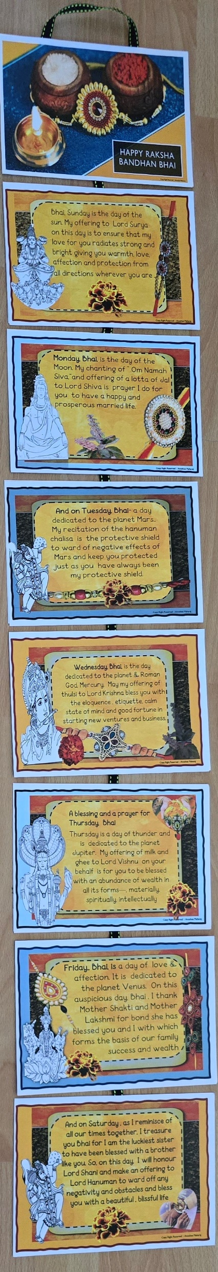

Whispers from the Universe Affirmation Cards

Affirmation cards have taken the self-care and mindfulness world by storm, and for good reason! These beautifully designed cards are packed with powerful, uplifting messages that can transform your mindset and daily routine. Each card is a tiny, tangible reminder of your worth, potential, and resilience, and can be used as a tool to quiet your mind, boost your confidence, and manifest your desires. Whether you're a busy professional looking for a quick pick-me-up during your morning commute, a student seeking motivation to tackle a challenging project, or simply someone looking to cultivate a more positive outlook on life, affirmation cards are the perfect companion. With a wide range of designs, from minimalist and modern to whimsical and artistic, there's an affirmation card out there to suit every style and preference. And the best part? They're ridiculously easy to use - simply get into a state of calmness , roll out the number mat provides and throw the healing stone onto the number mat. Draw and read the card on the number the healing stone has landed.
With affirmation cards, you can turn your daily routine into a ritual of self-love and empowerment. Its also a fun activity to play at a high tea with friends. Start living the life you truly deserve.

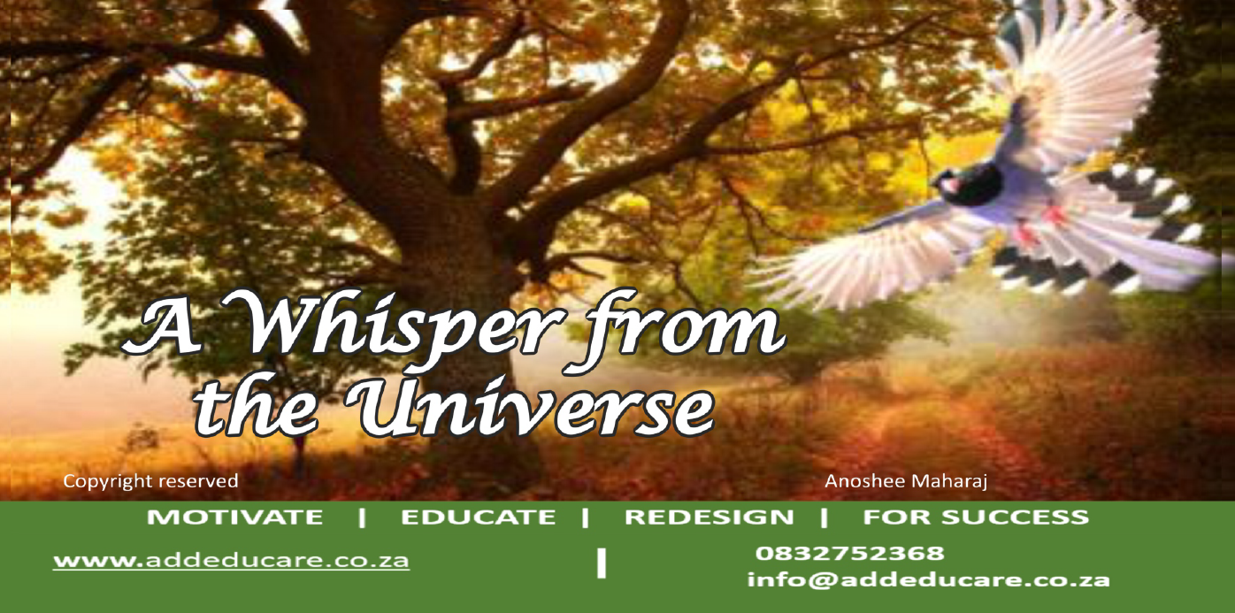

Our Shadi Mubarak Game

"Shadi Mubarak" - the ultimate wedding game that's taking the world by storm! This addictive game has become the go-to activity for friends and family to celebrate the union of two beloved individuals and is ideal for the pre wedding festivities. The game is simple yet oh-so-fun: players take turns in performing activities, asking questions and soliciting feedback from team members who are closest and dearest to the wedding couple. With its infectious energy and user-friendly format, "Shadi Mubarak" has become the perfect way to spice up any wedding celebration. Whether you're a bridezilla, a groom-to-be, or just a wedding guest looking for a good time, this game is sure to bring the house down and create unforgettable memories. So, get ready to join the "Shadi Mubarak" revolution and experience the ultimate wedding party game!

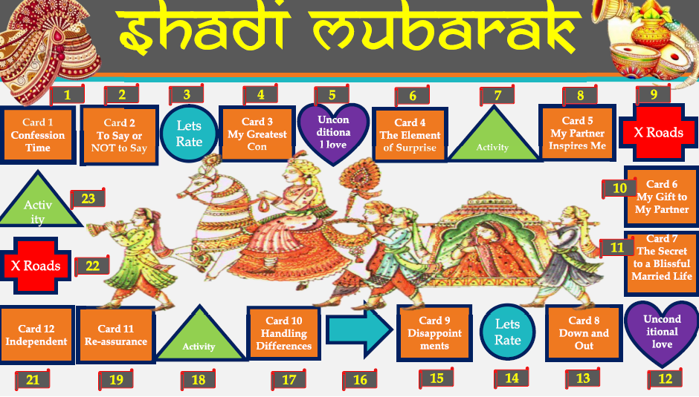

Mehndi Games

Get ready to add some fun and excitement to your mehndi celebration with these trendy games that are sure to delight your guests! As the henna designs take shape on your hands and feet, why not make it a memorable experience with some engaging activities? Start with a "Guess my identity" game, where you test your friends' knowledge about Indian culture, traditions, and henna-related facts. We have put together and rolled out a fantastic mehndi program with lots more interactive games to break the ice and get your guest chatting. All The winner gets a prize. And finally, end the night with a "Mehndi Dance Party" where you can play popular Indian music and have a blast dancing the night away with your friends. With these fun and trendy games, your mehndi celebration is sure to be an unforgettable experience that your guests will cherish forever! Contact us and let us create memorable moments for a life time.

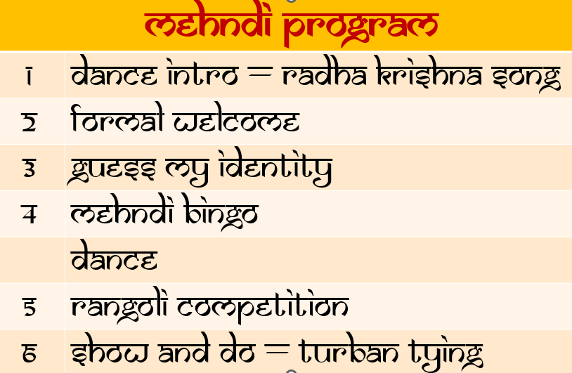

Customized greeting cards
- Customized notebooks

In association with La Réflexion Wellness SPA we have launched our wellness programs

Up and Coming Programs

- The Shadi Mubarak Wedding Journal

